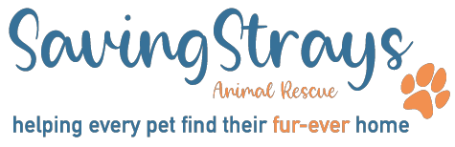
SAVING STRAYS ANIMAL RESCUE
GIFT AID DECLARATION FORM

Boost your donation by 25p of Gift Aid for every £1 you donate.

If you are a UK taxpayer, using Gift Aid means that for every £1 you give, Saving Strays Animal Rescue can claim another 25p from HM Revenue and Customs. Gift Aid is reclaimed by Saving Strays Animal Rescue from the tax you pay for the current tax year. Your address is needed to identify you as a current UK taxpayer.

Please complete this form and return to: Saving Strays Animal Rescue, either by DocuSign, email to savingstraysbolton@gmail.com or by post to 63 Kentfield Drive Bolton BL1 8FX.

Gift Aid Declaration

In order to Gift Aid your donation you must tick the applicable box below:

Multiple Donations

I want to Gift Aid my donation of £ and any donations I make in the future

Or

Single Donation

I want to Gift Aid my donation of £

TO: SAVING STRAYS ANIMAL RESCUE – Charity Number 1200632

I am a UK taxpayer and understand that if I pay less Income Tax and/or Capital Gains Tax than the amount of Gift Aid claimed on all my donations in that tax year, it is my responsibility to pay any difference.

My details are:

First Name: Surname:

Home Address:

Postcode: Date:

Please let us know straight away if you:
- want to cancel this declaration
- change your name or home address
- no longer pay sufficient tax on your income and/or capital gains to cover the tax we reclaim

Higher rate tax payers
If you pay Income Tax at the higher rate or additional rate you can claim additional tax relief by including all your Gift Aid donations on your Self Assessment tax return or ask HM Revenue and Customs to adjust your tax code.

